**5. Improvements**

**5.1 Desired future process**

The desired future process derives from the customer expectations for services that would give them more options, and ultimately make their lives more convenient. As previously mentioned in the above chapters, the gap lies in the missing premium services that customers may demand when they receive their parcels. A parcel may contain not only the commodity itself, but also sometimes it contains a sense of importance, an urgency so that the customers want to receive them directly, rather than leaving it on the front porch or next-door neighbor.

As last-mile delivery is gradually disrupting traditional business models, customers preferences also change drastically when more customers are willing to pay more for premium options [(McKinsey&Company)](https://www.mckinsey.com/industries/travel-logistics-and-infrastructure/our-insights/how-customer-demands-are-reshaping-last-mile-delivery?ssp=1&darkschemeovr=1&setlang=en&cc=NL&safesearch=moderate). In addition, the option diversity and quality of delivery services are major decision-making criteria for customers. Therefore, it would benefit DHL core strategic goals to start thinking about how they can improve their services to remain competitive in the future. It does not necessarily mean that the premium services must be available soon, but it is sensible to start laying foundation for such development through adaptable, flexible HR organization, operation, and IT.

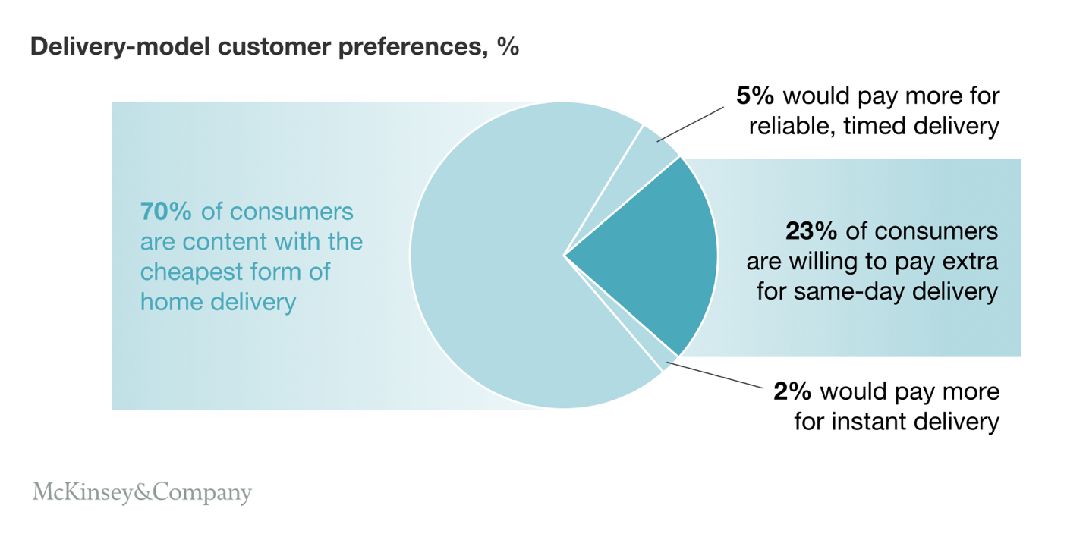

**5.2 Approach and Method**

Improving the business process requires a thorough understanding of the current operating situation, from the general procedures to trivial details and exceptions. To achieve this condition, several methods are required and listed below.

**Business Process Re-Engineering**

BRP is a business management method that focuses on analyzing and designing new workflow and processes. The main purpose of this method is to help companies rethink how they offer their services to the customers, how they can cut down operational costs, and remain competitive in the market. For the method to be implemented efficiently, the following steps need to be taken in consideration:

1. Identify the reason for change

The shift in customer expectations challenges traditional delivery methods and opens new space for other competitors to jump in the market. To remain as a top service provider, DHL offers new premium services to enhance customer satisfaction, gain a competitive edge in the logistics field, and open a new revenue stream through new services offering.

2. Establish a BPR team

A dedicated, cross-functional BPR team is necessary and crucial for the success of the new services. Team members should comprise of various departments (e.g.: logistics, customer service, IT, finance, etc.) but it also should contain members from senior management, experienced project managers, reengineering leaders. Leadership from senior management will provide direction, guidance, and alignment with organization goals. In addition, it will be valuable to the team if they have some operations managers of critical business teams who have direct insights into the daily delivery operations.

3. Set key performance indicators and constant monitor

The success of the redesigned process should be measured in a quantitative manner to ensure the new process delivers an enhanced value. Therefore, it is essential to pick the right metrics, or Key Performance Indicators (KPIS) depending on the process that the business is trying to improve. For a premium delivery option, relevant KPIs might include on-time delivery rates, customer satisfaction scores, and operational efficiency. These KPIs will not only serve as quantifiable targets but also a way for the BPR team to monitor progress and identify areas for improvement, making the newly enhanced process realistically feasible.

4. Design a future state

After the initial analysis of the core business process and gathering enough benchmarks of the current process, it is time to use the information to develop a desired future state of operation. The future operation must outline the end-to-end process of the premium delivery services. This will include a revamp of logistics IT systems, route optimizing algorithm, real-time tracking systems to incorporate the new features offered to the customers. Additionally, the redesign also involves changes in the warehouse operations, vehicle loading strategies, and especially driver schedules to adapt to the higher requirements for the premium service.

5. Testing new processes and evaluation

To reduce the unexpected risk in full-scale implementation, it is advisable to do a pilot phase of the new services in a small, controlled environment. The company could select a specific geographic area or a specific set of customers to test the new processes. Using the previously established KPIs, the BRP team can gather some field data and actual feedback from a controlled set of customers. These results will be used for necessary adjustments to the process, system, operation to ensure the new services meet those desired standards and customer satisfaction before full-scale roll-out.

6. Change management and roll-out

The final step of BPRs involves several change management principles to facilitate the new delivery process of premium services across the organization. This can be done in several ways such as top-down training programs for all relevant employees to ensure everyone understands how the new mode of operation works. Clear communication also plays a key role in this change as it will provide ongoing support if unexpected challenges, problems, exceptions arise. Therefore, engaging and preparing the workforce is extremely critical to reduce initial resistance and establish a smooth transition to the new model.

**Continuous Improvement**

In addition to the BPR, the “Continuous Improvement” methods, originally rooted in principles with Lean and Six Sigma, offer a dynamic approach to improve the newly designed process. It is almost impossible to design a perfect operation mode in the beginning so the addition of Continuous Improvement will help the business increase efficiency and reduce waste through steady, incremental changes. The method has several characteristics such as iterative cycle (which seek small, regular improvements to the process rather than radical ones), employee involvement (as the frontline of the business, they can frequently offer valuable insights), and data-driven nature (to aid the decision-making process during changes and propose new future developments). For these reasons, the dual approaches safeguard DHL’s competitive edge and ensure a high commitment to customer needs and satisfaction.

**5.3 Suggestions**

In light of the evolving customer expectations and the competitive landscape as detailed in previous subsections, the approach towards enhancing DHL's delivery services should be multifaceted. The inception of a new European Innovation Center by DHL, aiming at pioneering sustainable logistics solutions, marks a significant stride towards embracing green innovations. This move not only underscores the company's commitment to sustainability but also aligns with the broader industry imperative for eco-friendly operations. (https://group.dhl.com/en/media-relations/press-releases/2023/dhl-breaks-ground-on-cutting-edge-european-innovation-center-in-germany-prioritizing-holistic-sustainability.html)

Moreover, the Logistics Trend Radar report, which aggregates insights from over 20,000 logistics professionals, underscores the pivotal role of advanced technologies such as Artificial Intelligence (AI), robotics, and Internet of Things (IoT) in shaping the future of logistics. These technologies, alongside sustainability initiatives, are positioned as key drivers for the next wave of service improvements(https://group.dhl.com/en/media-relations/press-releases/2020/dhl-logistics-trend-radar-unveils-trends-that-will-shape-logistics-in-the-future.html). The accelerated shift towards digital and automated solutions, further catalyzed by the global pandemic, presents DHL with a clear directive to not only continue but also scale its investments in these areas to enhance operational efficiency, customer service, and to develop innovative services that address large-scale problems.

Addressing the workforce's readiness to adapt to these advancements is equally crucial. The continuous training and upskilling of employees to handle increasingly technologically sophisticated operations will be central to maintaining DHL's competitive edge. This focus on human capital underscores the recognition of the vital role the workforce plays in the seamless integration and execution of new technologies and processes.

The expansion of premium service offerings emerges as a natural progression in DHL's strategy to meet and exceed customer expectations. By leveraging insights from technology investments and sustainability initiatives, DHL can offer more personalized and urgent delivery options, thereby not only enhancing customer satisfaction but also opening new revenue streams.

In conclusion, the suggestions for DHL's future enhancements are deeply rooted in the integration of sustainable practices, the adoption of cutting-edge technologies, the importance of workforce upskilling, and the expansion of premium service offerings. By focusing on these areas, DHL can ensure its services are not just meeting the current demands but are also geared for future challenges and opportunities, thereby reinforcing its leadership in the global logistics sector.

Extra Reference Articles

Hsieh and Yuan (2016) highlight the importance of real-time measurement of customer expectations to manage and fulfill them effectively, emphasizing the need for service providers to adapt and respond dynamically to customer needs (Hsieh & Yuan, 2016).

Bonfanti et al. (2023) suggest that online food ordering and delivery service quality can be improved by managing customer expectations through strategies such as customer reassurance, flexibility, continuous improvement, customer education, adaptation to customers' requirements, and monitoring of exceptions. This approach is relevant for any premium service offering (Bonfanti, Rossato, Vigolo, & Vargas-Sánchez, 2023).

Zhu, Freeman, and Cavusgil (2018) explore the macro-environmental influences on service culture and quality delivery from a cross-national context, providing insights into the complexity of meeting diverse customer expectations in a globalized service environment (Zhu, Freeman, & Cavusgil, 2018).

Zhou et al. (2020) discuss the psychological factors influencing online consumers' adoption of self-service parcel services for last-mile delivery, emphasizing the need for premium delivery services to consider these factors to enhance customer satisfaction (Zhou et al., 2020).

Araújo et al. (2022) investigate logistics service expectations and delivery methods in last-mile delivery, using a Fuzzy Analytic Hierarchy Process model to assess how service expectations influence delivery preferences. This study underscores the importance of aligning delivery methods with customer expectations to ensure satisfaction (Araújo et al., 2022).

(bibtex version)

@article{Hsieh2016,

title={Can Customer Expectations be Measured in Real Time?},

author={Yen-Hao Hsieh and S. Yuan},

journal={Int. J. Inf. Technol. Decis. Mak.},

year={2016},

volume={15},

pages={119-150},

doi={10.1142/S0219622015500352},

}

@article{Bonfanti2023,

title={Improving online food ordering and delivery service quality by managing customer expectations: evidence from Italy},

author={A. Bonfanti and Chiara Rossato and Vania Vigolo and Alfonso Vargas-Sánchez},

journal={British Food Journal},

year={2023},

doi={10.1108/bfj-08-2022-0694},

}

@article{Zhu2018,

title={Service quality delivery in a cross-national context},

author={Ying Zhu and S. Freeman and S. Cavusgil},

journal={International Business Review},

year={2018},

doi={10.1016/J.IBUSREV.2018.03.002},}

@article{Zhou2020,

title={Understanding consumers’ behavior to adopt self-service parcel services for last-mile delivery},

author={Min Zhou and Lindu Zhao and N. Kong and Kathryn S. Campy and Ge Xu and Guiju Zhu and Xianye Cao and Song Wang},

journal={Journal of Retailing and Consumer Services},

year={2020},

volume={52},

pages={101911},

doi={10.1016/J.JRETCONSER.2019.101911},

}

@article{Araujo2022,

title={A Fuzzy Analytic Hierarchy Process Model to Evaluate Logistics Service Expectations and Delivery Methods in Last-Mile Delivery in Brazil},

author={Fernanda Alves de Araújo and João Gilberto Mendes dos Reis and Marcia Terra da Silva and E. Aktas},

journal={Sustainability},

year={2022},

doi={10.3390/su14105753},

}